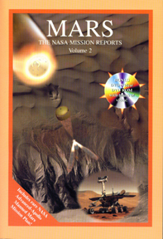
MARS
The NASA Mission Reports
Volume 2

ISBN 1894959051
$28.95

This latest volume brings the exploration of Mars up to date. Including the latest results from the amazingly successful Mars Exploration Rovers, Spirit and Opportunity, as well as progress reports from the Mars Global Surveyor and Mars Odyssey missions.

Includes: DVD-V/DVD-ROM featuring:

Exclusive interviews with Mars Rover Mission Scientist Steve Squyres, Senior Flight Engineer Rob Manning, Mission Manager Jim Eriksen, the complete Cornell animation of the Rovers created by Maas Digital, a NASA animation of a proposed Manned Mars mission, the exciting mission control broadcast of the landing of Opportunity in Meridiani Planum and as an added extra special bonus, extremely rare video of Dr Wernher von Braun filmed in 1976 at the occasion of his last public speech about Mars exploration.

Thousands of still images from Opportunity and Spirit.

Four more complete Mars books on the disc.

"The DVD alone is worth the price of the book." Spaceflight

"You've done it again: Found the coolest stuff about Mars and put it into
one, big, bounteous package unlike anything else that's available. And the
DVD is super!" Andy Chaikin author of "A Man on the Moon."

"If you religiously followed every recent spacecraft mission to the red planet but are afraid that you may have missing something, then here's your salvation." Sky & Telescope

